
Land Information Ontario (LIO) Warehouse
Data Class Name: Municipal Boundary - Lower and Single Tier
Documentation
Produced by: Spatial Data Support Unit
Ministry of Natural Resources and Forestry
Date: February 15, 2024

Purpose

This document provides additional information to support the use of geospatial data. The Physical Model Diagram provides a visual representation of the relationships in the data class. The Data Change History lists all the modelling and access changes that have occurred during the lifecycle of the data class. A data description identifying table and field names is available upon request.

Need Assistance?
Please contact LIO Support at lio@ontario.ca or 705-755-1878 if you require help.

Physical Model Diagram
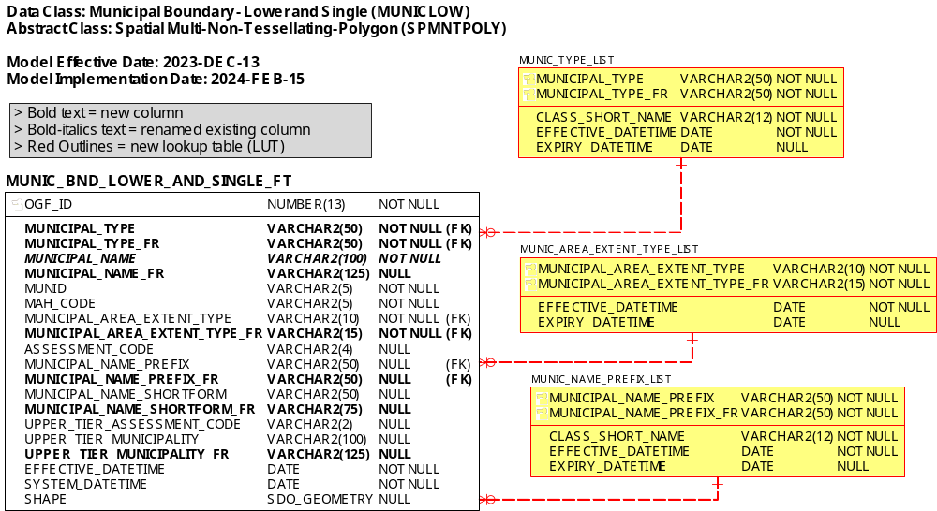

Data Class Change History
Data Class Name: Municipal Boundary - Lower and Single Tier
Data Class Short Name: MUNICLOW
Date  YYYY-MM-DD | Details of Change
2024-02-15 | Renamed columns:  - OFFICIAL_MUNICIPAL_NAME to MUNICIPAL_NAME  Dropped columns:  - CLASS_SUBTYPE + CLASS_SUBTYPE_NUM  - GEOG_UNIT_DESCR  - GEOMETRY_UPDATE_DATETIME  Dropped column check constraints: (both classes - replaced by lookup tables)  MUNIC_BND_LOWER_AND_SINGLE_FT  - MUNICLOW_CLASS_SUBTYPE_FK  - MUNIC_BND_LOWER_EXTENT_CHK  New columns:  - MUNICIPAL_TYPE (replaces CLASS_SUBTYPE)  - MUNICIPAL_TYPE_FR  - MUNICIPAL_NAME_FR  - MUNICIPAL_AREA_EXTENT_TYPE_FR  - MUNICIPAL_NAME_PREFIX_FR  - MUNICIPAL_NAME_SHORTFORM_FR  - UPPER_TIER_MUNICIPALITY_FR  New lookup tables:  - MUNIC_TYPE_LIST  - MUNIC_AREA_EXTENT_TYPE_LIST  - MUNIC_NAME_PREFIX_LIST  Drop associations to all CLASS_ tables  - CLASS_DATABASE_REFERENCE  - CLASS_JUSTIFICATION  - CLASS_OTHER_INFORMATION  - CLASS_PARTY_ROLE  - CLASS_SOURCE  - CLASS_SUBTYPE_LIST (parent)  - CLASS_SUPPORTING_MATERIAL  - EXTERNAL_REF_TYPE_LIST  - ROLE_TYPE_LIST  - SOURCE_LIST
2012-06-14 | GAAR Project Data Class conversion (remove GEOG_UNIT, replace FMF_OBJECT_ID with OGF_ID, and replace old Common Tables with new CLASS_ shared tables)
2008-08-25 | Data Class renamed: from "Municipal Lower" to "Municipal Boundary - Lower and Single Tier". Kept same Short Name (MUNICLOW).
2006-07-31 | NEW Data Class: "Municipal Unit, Lower" (MINICLOW). Replaces "Municipal, Lower Tier" (MUNLOWER).
Data Description
Please refer to the GeoHub metadata record for the data description.

